Course registration instructions

Semester 2 2019/2020

We are glad to present the course registration instructions at Université Paris-Dauphine for the second semester 2019-2020 (Fall semester).

Please read the course information and registration instructions below carefully.

Course offer

The course offer for exchange students with syllabi and courses descriptions for the second semester 2019-2020 is available on our [website](https://www.dauphine.fr/en/international-exchange/coming-to-dauphine-as-an-exchange-student.html). This list is not exhaustive, you will find new courses during the registration.

The course offer for exchange students is organized by academic field:

* + Economics
  + Business
  + Social Sciences & Law
  + Mathematics and Computer Science (and all the MIDO department courses)
  + Electives courses
  + French as a Foreign Language (FLE)

Each course is part of one of the three academic departments at Paris-Dauphine (LSO, MSO, MIDO) or the International Affairs office. The codification of the courses indicates the department and the level:

|  |  |  |  |
| --- | --- | --- | --- |
| **Department** | **Level** | **Code** | **Field** |
| **International Affairs Office** | **On the syllabus (mostly undergraduate)** | **0I**XXXXXX | **Economics, Business,**  **Social Sciences and Law**  **French as a Foreign Language** |
| **LSO Department** | **Undergraduate** | **3L**XXXXXX | **Economics, Business,**  **Social Sciences and Law** |
| **MSO Department** | **Graduate** | **4M**XXXXXX  4**M**XXXXXX | **Economics, Business,**  **Social Sciences and Law** |
| **MIDO Department** | **Undergraduate** | **1A**XXXXXX  **2A**XXXXXX  **3A**XXXXXX | **Mathematics &**  **Computer Sciences** |
| **Graduate** | **4A**XXXXXX |

You can select courses in all fields and departments, on the condition that you fit the pre-requisites.

* **For MIDO courses**, the registration will have to be approved by the academic advisor for international students as the mathematics prerequisites are important.
* **Registration in 2nd year Master -5MXXXXX- classes are restricted to graduate students** and subject to the approval of the course coordinator and MSO or MIDO departments.

**French as Foreign Language (FLE) courses**

Université Paris-Dauphine offers you 2 options to learn/improve your French skills from beginner to advanced:

1. January Intensive French Seminar
2. Semester courses

The seminar and courses are organized by level from beginner to advanced according to the Common European Framework of Reference for Languages (CEFR), please find the level grid attached.

1- January Intensive French Seminar:

* From January 7th to January 10th, 2020;
* It is a 20 hours in-class course and 4 hours online through the online platform MyCourse;
* The fee is 200€. This amount will have to be paid once you arrive at Université Paris-Dauphine (no refund will be possible);
* Attending this seminar will allow you to get 3 ECTS credits.

2- Semester courses for the 2nd semester:

* These courses are free;
* They take place from January 13th, 2020 to April 24th , 2020;
* To register, you must include the course(s) in your learning agreement on the registration platform, credits transfer depend on home institution;
* A semester course is worth 6 ECTS.

You can include up to 2 FLE courses in your course selection and add the Intensive French Seminar.

You must register in a group at your level or one below or one above (Ex: You have a B1 level, you can register in an A2, B1 or B2 course). Please keep in mind you must follow this procedure to be able to register for FLE classes.

|  |  |
| --- | --- |
| **From October 8th to October 24th** | **An e-mail was sent to you on October 8th with the application form to complete the FLE questionnaire online if you wish to take French as a Foreign language classes.** |
| **From October 25th to October 28th** | **Take the online level test once you have received the link.**  **You will receive the results by e-mail after October 29th.**  **You do not need to take the online level test if:**   * + **You have a B2 level or above and you can send a proof of proficiency by e-mail at courses.exchange@dauphine.fr by May 12th.**   + **You have never studied French before.** |
| **From October 31st to November 15th** | **Register via the online course registration platform:**   * + **Once you know your level, you can register in the appropriate level group/class**   + **To register, add the seminar and/or 1 or 2 FLE classes in your course selection** |

Credits

You can choose up to 30 ECTS (European Credit Transfer System) per semester:

* + You might see some department course descriptions indicating 2, 3, 4, 5 or 6 ECTS, but **exchange students will only receive either 3 or 6 ECTS for each course**. The correct number of ECTS for each course is on the registration platform.
  + The International Affairs office courses are worth 3 or 6 ECTS.
  + The Intensive French Seminar is worth 3 ECTS. It can be included either in your 30 ECTS courses selection OR added on top of it.

The exact number of courses or credits you should select also depends on your home institution. Your academic advisor or exchange coordinator should inform you on the number of courses and credits required to pass the semester.

Campus Location

* + Porte Dauphine Campus: The Université Paris-Dauphine building is located at Porte Dauphine.
  + La Défense Campus (Pôle Universitaire Leonard de Vinci – PULV): This campus is a few metro stops away from the main building. Only some Master level finance courses are held there, and you will need an access card to enter the building.

Academic Calendar

When selecting your courses, please be aware that the academic calendar varies according to departments and fields. Some exams can be scheduled after Christmas break. We also remind you that the International Affairs office organizes a Welcome Week from **January 6th to January 10th, 2020.** Your presence at these events is **compulsory.**

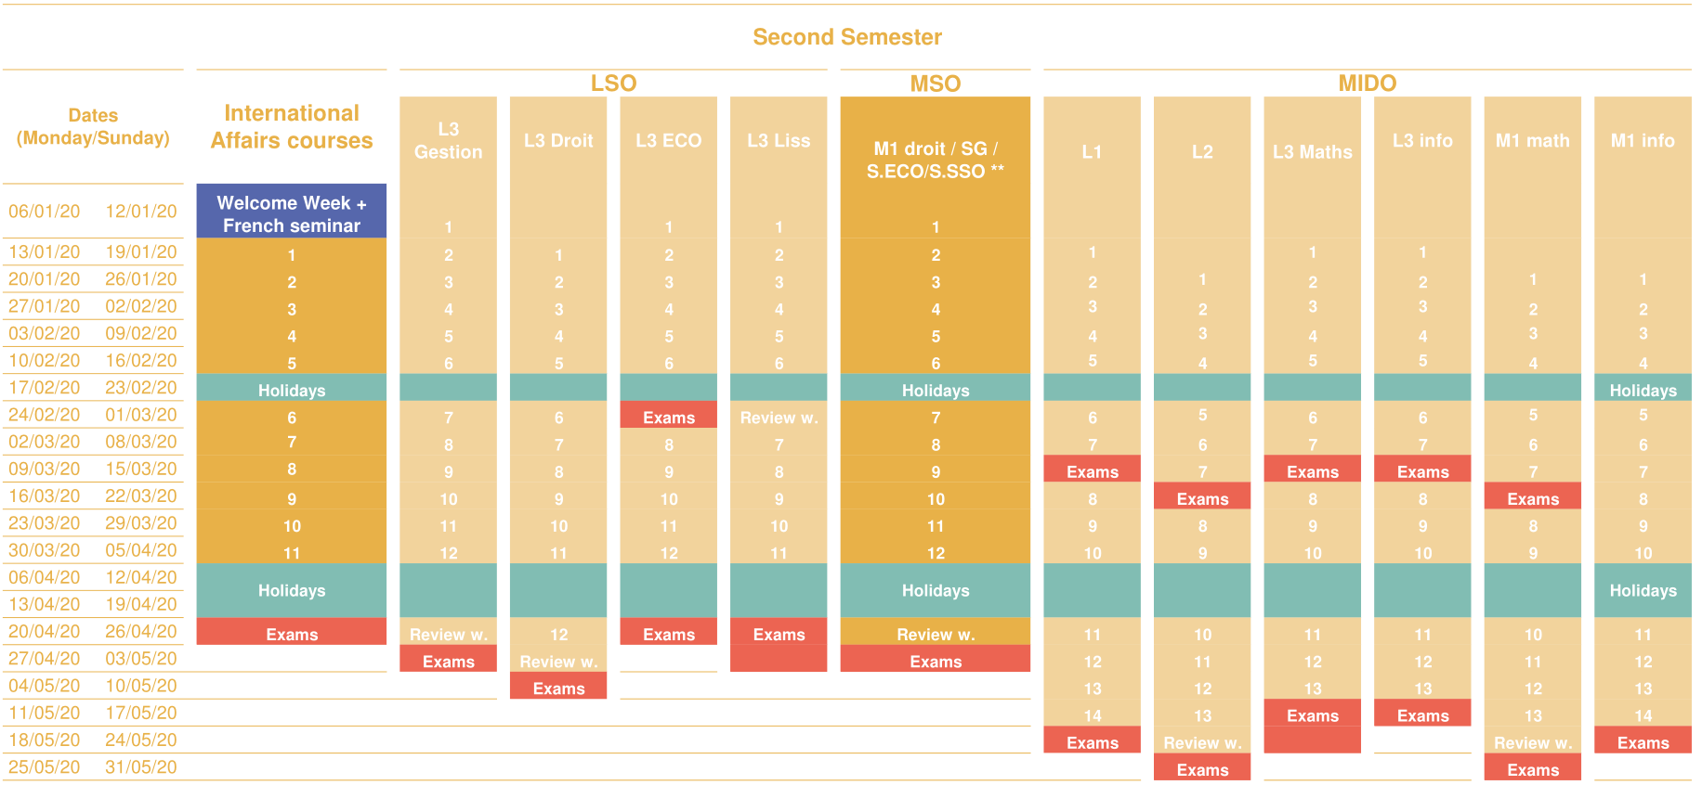

Courses Schedules

Some schedules will only be available in November, therefore the course registration platform will re-open from December 2nd to December 9th to allow you to modify your courses selection if time conflicts appear. You will be notified by e-mail.

Courses can include either one lecture or a lecture and a practical class, called “Travaux Dirigés” ou “TD”. **Practical classes are mandatory.**

Course registration procedure

You will be able to register online for the 2nd semester courses from **October 3****1st (02:00 PM) to November 15th, 2019 (02:00 PM):**

* The course registration is done on a “first come, first served” basis.
* Please make sure your choice of courses is approved by your home institution before validating your selection. **You will need to send us your signed learning agreement Friday 20th December.**
* Before you log in, we recommend you have alternative courses approved by your home university in advance in case a course is full or there is a time conflict when you select it on the platform.
* Your **Dauphine learning agreement** and yourschedule will be created once you submit the selection.

**Step 1 – Log in on the course registration platform**

Please follow this link to access the platform with the information below:

<https://preinscription.dauphine.fr/>

* + Enter the email address we used to send you this procedure. **(It will work only after 2:00 PM October 31st)**
  + Password: enter your birthday using the format DD/MM/YYYY

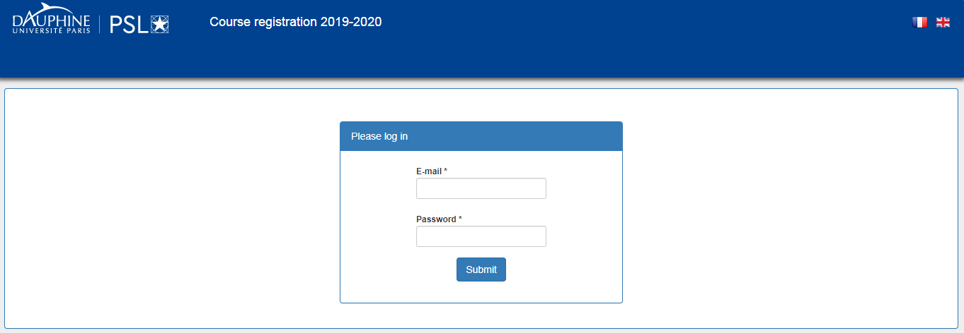

**Step 2 – Course selection**

Click on “Select courses” to start your course registration.

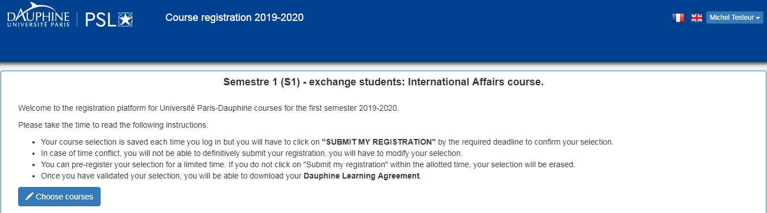

You can navigate through the different fields to look at available courses.

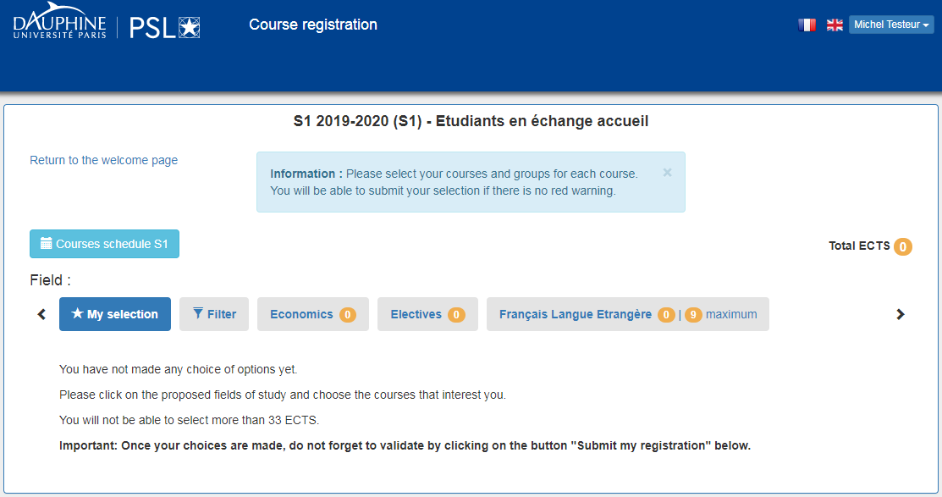

To select a course, first select a group or “TD”, then click on “Choose”.

Once you have selected a course, the total number of ECTS (upper right corner) adjust automatically. The number of ECTS per field also appears next to the field title.



If you want to remove the course from your selection, just click on “Remove”.

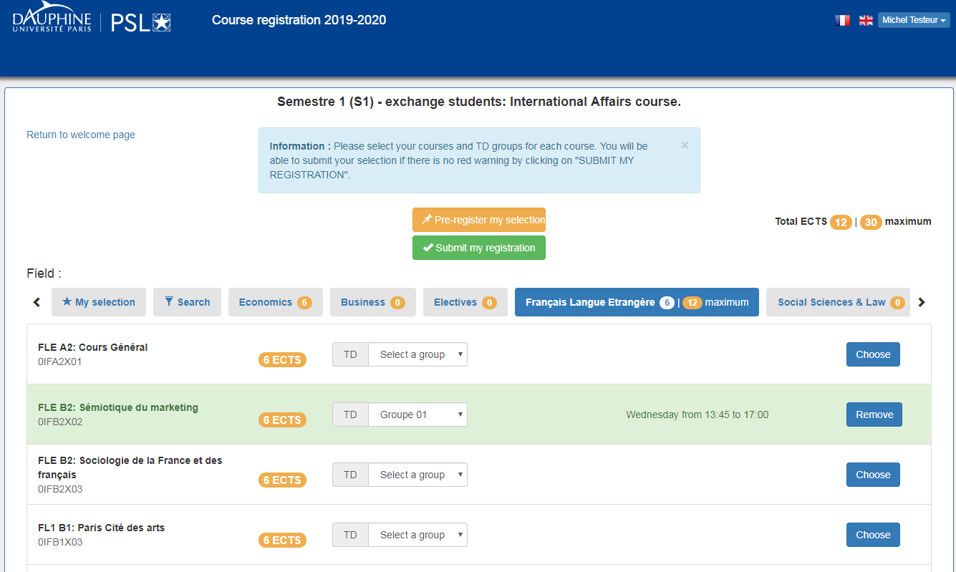

The “Search” button allows you to browse through each field by course title, code or level.

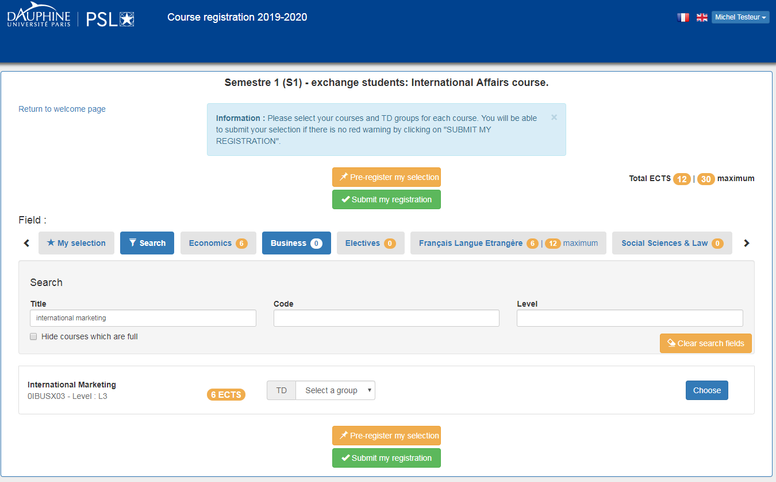

To have an overview of your course selection, you can click on “My selection”.

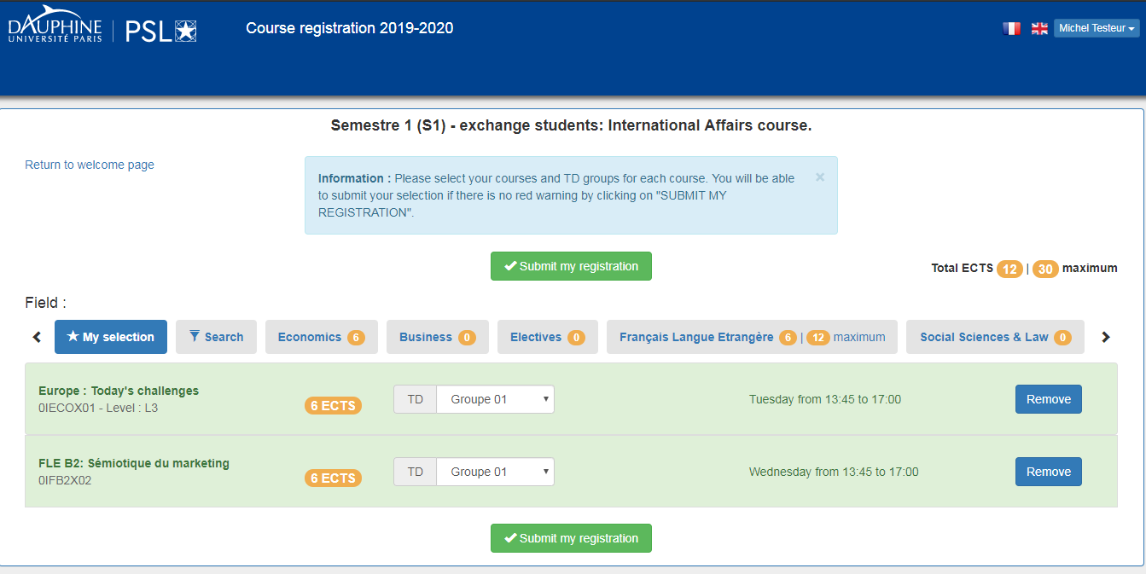

**Step 3 – Pre-register or validate definitively your course selection**

Once you have clicked on “Choose”, your selection is saved, even if you log out but your spot is not guaranteed in the class.

**You can pre-register your choices before validating definitively your selection by clicking on “Pre-register my choices”. Your selection will be saved for 48 hours and register your spot in the class selected. If you do not submit your selection within this period, your selection will be erased.**

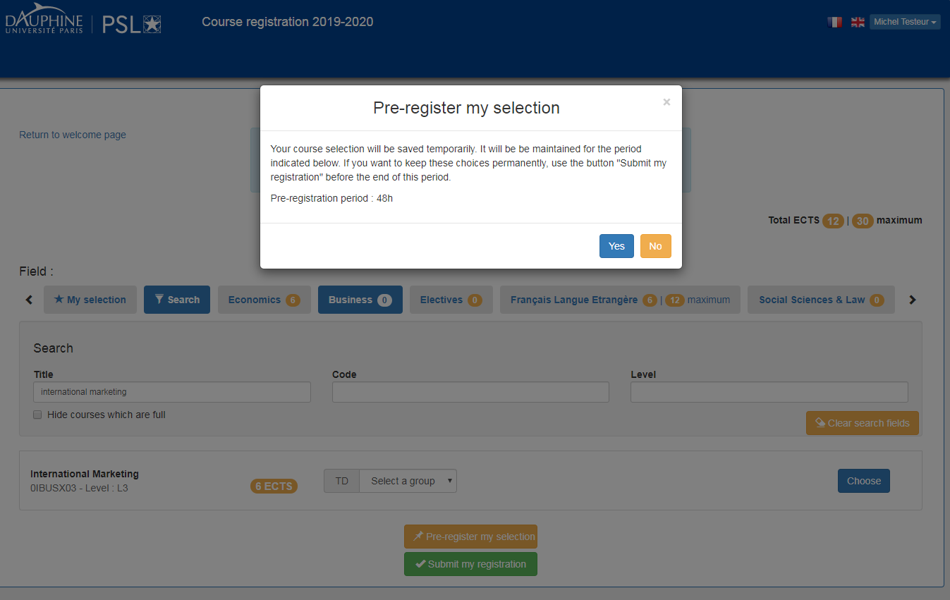

When you log in again, you will see your pre-registered courses. To modify or validate definitively your selection, click on “Choose courses”.

You can add new courses and click on “Pre-register my selection” again. Be aware that the application registers the time you pre-register each class, therefore if you add a new class, you still to submit your selection by the time limit of the first class you added.

For example, if you select “Marketing of Luxury Sector” on November 04th at 3pm, pre-register the class and log out. Then you add the class “FLE B2 Sémiotique du marketing” on November 04th at 6pm. You still need to submit your registration by November 06th at 3pm, otherwise you will lose your spot in “Marketing of Luxury Sector”.

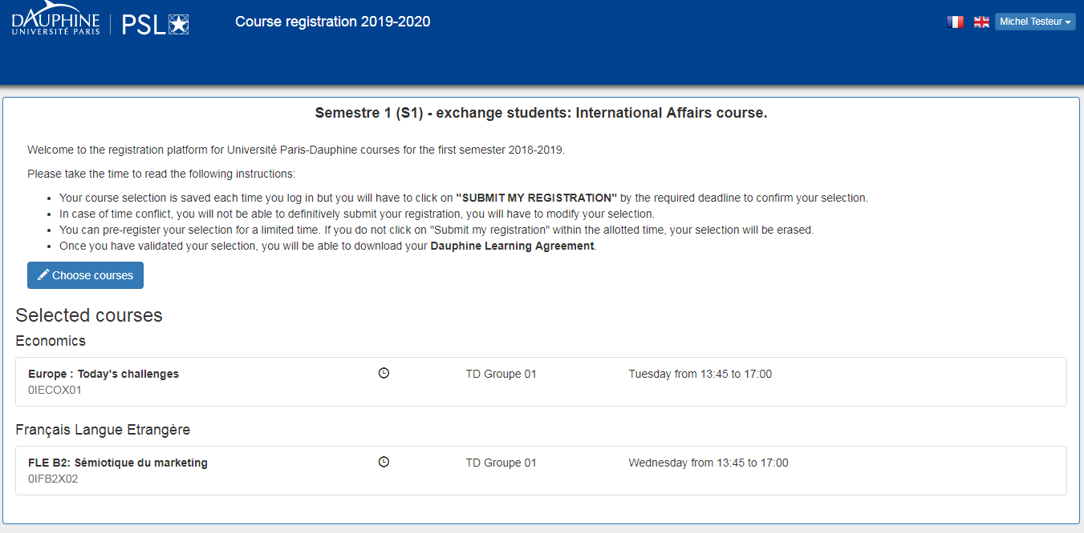

Click on « Submit my registration » to validate your selection definitively. **You will not be able to make any change after that.**

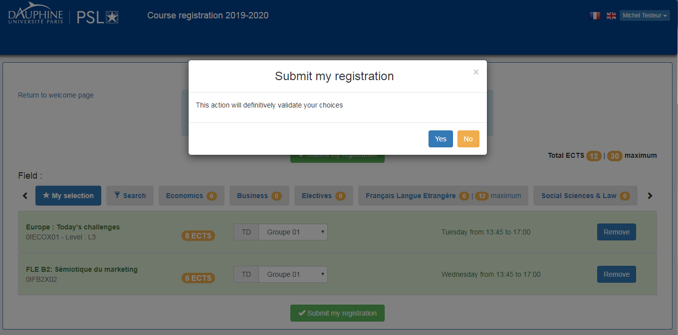

**Step 4 – Download your Learning Agreement**

Once you validate your selection, you can download your Dauphine Learning Agreement.

You should have it signed by your home institution and send it to [courses.exchange@dauphine.fr](mailto:courses.exchange@dauphine.fr).

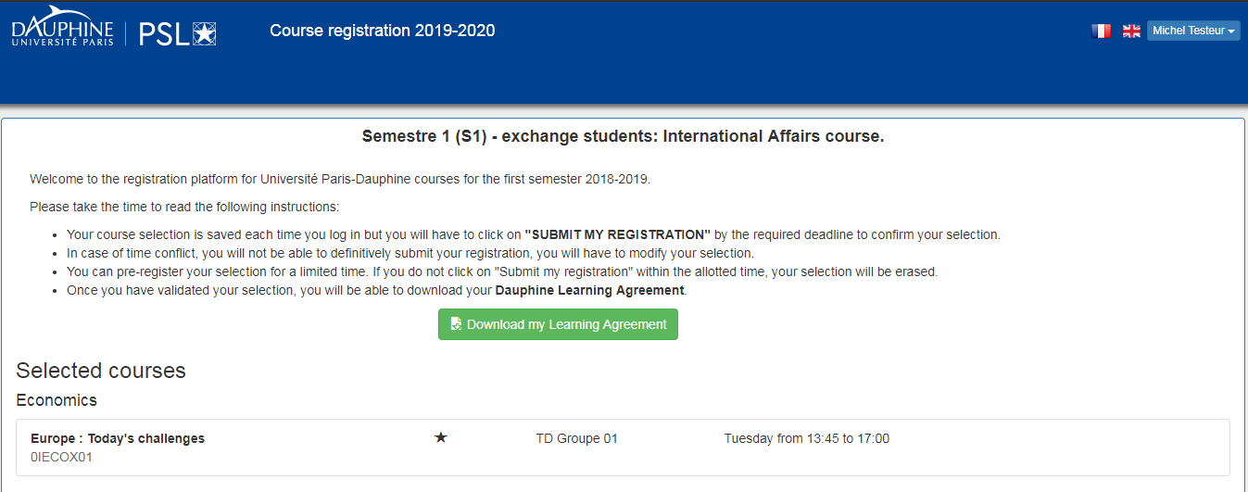

Contact

If you have any questions, please feel free to contact our courses coordinators at:

[courses.exchange@dauphine.fr](mailto:courses.exchange@dauphine.fr)

|  |  |
| --- | --- |
| **Coordinator** | **Academic field** |
| Baptiste BIANCARDINI  Latifah SABIN | Economics  Business  Social Sciences & Law  Mathematics and Computer Science  Electives courses |
| Marine ROY | French as a Foreign Language |

We look forward to welcoming you in January!